**Department of Electrical and Computer Engineering**

**North South University**



**Junior Design Project**

**Bus Service Automation**

**Mohammad Rashedul Alam ID # 1511384642**

**Sakib Mukter ID # 1520268042**

**Muhammad Abeer Tahmeed ID # 1510963042**

**Kawcher Ahmed ID # 1520667642**

**Faculty Advisor:**

**Mirza Mohammad Lutfe Elahi**

**ECE Department**

**Senior Lecturer**

**Summer, 2018**

**Declaration**

This is to declare that no part of this report or the project has been previously submitted elsewhere for the fulfillment of any other degree or program. Proper acknowledgement has been provided for any material that has been taken from previously published sources in the bibliography section of this report.

.........................................................

Mohammad Rashedul Alam

ECE Department

North South University, Bangladesh

........................................................

Sakib Mukter

ECE Department

North South University, Bangladesh

.........................................................

Muhammad Abeer Tahmeed

ECE Department

North South University, Bangladesh

.........................................................

Kawcher Ahmed

ECE Department

North South University, Bangladesh

**Approval**

The Junior Design Project entitled “**Bus Service Automation**” by Mohammad Rashedul Alam (ID#1511384642), Sakib Mukter (ID#1520268042) , Muhammad Abeer Tahmeed (ID#1510963042) and Kawcher Ahmed (ID#1520667642) has been accepted as satisfactory and approved for partial fulfillment of the requirement of BS in CSE degree program on May, 2017.

|  |
| --- |
| **Supervisor’s Signature** |
|  |
| **Mirza Mohammad Lutfe Elahi**  **Senior Lecturer**  Department of Electrical and Computer Engineering  North South University  Dhaka, Bangladesh. |
| **Department Chair’s Signature** |
| **Dr. Shazzad Hosain**  **Associate Professor**  Department of Electrical and Computer Engineering  North South University  Dhaka, Bangladesh. |

**Acknowledgement**

First of all, we would like to express our profound gratitude to our honorable course instructor, **Mirza Mohammad Lutfe Elahi,** for his constant and meticulous supervision, valuable suggestions, his patience and encouragement to complete the project.

We would also like to thank the ECE department of North South University for providing us with the opportunity to have an industrial level design experience as part of our curriculum for the undergraduate program.

Finally, we would like to thank our families and everybody who supported us and provided with guidance for the completion of this project.

**Abstract**

Automatic Fare Collection and Bus Tracking System implemented by RFID card and GPS. RFID card is given to the passenger and when passenger gets into the bus he has to point the card in the RFID reader and after reaching destination he will again point in the RFID. System will automatically calculate the fare and deduct the money automatically. Hence people do not have to carry the money and they don’t have the problem in giving the right change to conductor. All the record will be updated automatically in the server continuously. An App will monitor the bus for amount of path taken by bus, status, number of passengers, distance information. App will continuously track the bus. It overcomes all the problems faced in bus with IOT based monitor system.

Table of Contents

Chapter 1 3

Project Overview 3

1.1 Introduction 4

1.2 Radio Frequency Identification and Detection(RFID) basics: 4

1.2.1 How RFID works 5

1.2.2 Applications of RFID 5

1.2.3 Pros and Cons 6

1.2.4 Performance 7

1.2.5 List of RFID frequency used commercially 7

1.3 Our proposed project 9

1.3.1 Description of the idea: 10

1.3.2 Difficulty 10

1.4 Motivation 11

1.5 Summary 11

Chapter 2 12

Related work 12

2.1 Introduction 13

2.2 Existing work related to RFID based Bus fare system 13

2.2.1 RFID Security Access Control System 13

2.2.2 RFID based Attendance System 14

2.2.3 RFID based Paid Car Parking 14

2.3 Research and publications RFID Fare System 15

2.3.1 AUTOMATIC BUS FARE COLLECTION 15

SYSTEM USING RFID 15

2.3.2 RFID-BASED AUTOMATIC BUS TICKETING: FEATURES AND TRENDS 15

2.4 Summary 16

Chapter 3 17

Theory 17

3.1 Introduction 18

3.2 Radio Frequency Identification and Detection (RFID) 18

3.2.1 Theory 18

3.2.2 Algorithm 22

3.2.3 Equations and calculation 23

3.3 Embedded System 25

3.3.1 Global Positioning System (GPS) 26

3.5 Summary 26

Chapter 4 27

Structure of the system 27

4.1 Introduction 28

4.2 Procedure and Functionality 28

4.2.1 Procedure 28

4.2.2 Functions 29

4.3 Workflow and Algorithms 30

4.3.1 Outline of the workflow 32

4.4 Equipment and Schematic Diagrams 33

4.5 Summary 35

Chapter 5 36

Google Distance Matrix API 36

5.1 Introduction 37

5.2 Google Maps API 37

5.3 Google Distance Matrix API 38

5.4 Summary 39

Chapter 6 40

The Microcontroller used in this system: Arduino Uno 40

6.1 Introduction 41

6.2 Arduino Uno 41

6.2.1 Hardware 42

6.2.2 Application 44

6.3 Pin out diagram of Arduino UNO 45

6.4 Summary 45

Chapter 7 46

Modules used in this system 46

7.1 Introduction 47

7.2 RC522 RFID Module 13.56MHz 47

7.3 GPS Module (NEO-6M) 48

7.4 LCD Display (16x2) 50

7.5 ESP8266 WIFI Module 51

7.6 Summary 53

Chapter 8 54

Mechanical Description 54

8.1 Introduction 55

8.2 Mechanical measurements and explanations 55

8.3 Summary 55

Chapter 9 56

Compliance with standards 56

9.1 Introduction 57

9.2 Compliance with IEEE standards 57

9.3 Compliance with US standards 57

9.4 Compliance with European standards 57

9.5 Summary 58

Chapter 10 59

Design Impact 59

10.1 Introduction 60

10.2 Economic impact 60

10.3 Environmental impact 60

10.4 Social impact 60

10.5 Political impact 60

10.6 Ethical impact 61

10.7 Health and safety impact 61

10.8 Manufacturability 61

10.9 Sustainability 61

10.10 Summary 62

Chapter 11 63

Results and Discussion 63

11.1 Introduction 64

**11.2 Result and findings of location tracing** 64

**11.3 Limitations** 64

**11.4 Summary** 64

Chapter 12 65

Project Budget & Timeline 65

12.1 Introduction 66

12.1 Project Budget 66

12.3 Project Timeline 67

Chapter 13 68

Conclusion 68

Bibliography 70

# Chapter 1

# Project Overview

### 1.1 Introduction

In our country specially in Dhaka there are so many buses which need lots of conductors to conduct the bus. It is a hassle. It consumes so many times and creates chaos among conductor and passengers.

People wait for buses for long time. But when the bus arrives, most of the time there are no seats available. It costs time, money and many more. So, we would like to introduce our idea about this hassle through our project. The project is Bus System Automation. So there will be no conductor needed to collect the fares and check for the vacant seats. Passengers have their RFID as their currency. There will be a device in the bus. When passengers will get in the bus they have to punch their RFID and the device will read the data and send it to server to start as his\her journey. Then it will update how many seats are available. And when passengers get down from the bus they will punch their RFID again and the device will calculate his/her fare through Google Map API. It will calculate the fare through distance covered. So if someone have emergency to get down from the bus, the fare will be shown as how much distance he covered. So it will be fair enough for passengers. People can also see when the bus will arrive and how many seats are available through our Android app. The Android app immediately get updated with the device in the bus.

## 1.2 Radio Frequency Identification and Detection(RFID) basics:

The Radio-frequency identification (RFID) is a wireless technology that uses low frequency radio signals ranging from 3 kHz to 300 GHz in order to transfer small bits of data between RFID devices [4]. An RFID device consists of two fundamental components: tags and readers [2]. The communication between the reader and the tag is achieved via the transmission of electromagnetic waves. A reader is used to magnetize the tag and decode the information from the tag. Tags store and process information stored in it [7]. A reader emits radio frequency signal which interacts with the tag. This energizes the pin or bar code producing its own magnetic field with a unique interference pattern which corresponds to a unique number which is read by the tag.

### 1.2.1 How RFID works

RFID belongs to a group of technologies referred to as Automatic Identification and Data Capture (AIDC). AIDC methods automatically identify objects, collect data about them, and enter those data directly into computer systems with little or no human intervention.

RFID methods utilize radio waves to accomplish this. At a simple level, RFID systems consist of three components: an RFID tag or smart label, an RFID reader, and an antenna. RFID tags contain an integrated circuit and an antenna, which are used to transmit data to the RFID reader (also called an interrogator). The reader then converts the radio waves to a more usable form of data. Information collected from the tags is then transferred through a communications interface to a host computer system, where the data can be stored in a database and analyzed at a later time.

### 1.2.2 Applications of RFID

RFID can be used in a variety of applications, such as:

* Electronic key for RFID based lock system
* Access management
* Tracking of goods
* Tracking of persons and animals.
* Toll collection and contactless payment
* Machine readable travel documents
* Smartdust (for massively distributed sensor networks)
* Airport baggage tracking logistics.
* Timing sporting events
* Tracking and billing processes

### 1.2.3 Pros and Cons

**Pros**

1. RFID tags are rugged and robust. It can work at extreme temperatures and harsh environment. This system works at a remarkably high speed, even in adverse conditions.
2. The tags are available in different shapes, sizes, types, and materials. The information on the read-only tag cannot be altered or duplicated. Read-write tags can be used repeatedly. The RFID tags always read without any error.
3. Direct physical contact between the tags and the reader is not required for the system to work. Radio frequency (RF) technology is used for communication using RFID.
4. Multiple tags can be read at the same time. The tags can be read in a bulk of 10 to 100 tags at a time. Reading is automatic and involves no labor.
5. RFID systems can identify and track unique items, unlike the bar code system which identifies only the manufacturer and the product type.
6. The entire system is very reliable which allows the use of RFID tags for security purpose.
7. The storage capacity of the RFID tags is greater than any other automatic identification and tracking system.

**Cons**

1. The main disadvantage is the high cost involved in this technology. The RFID system is costlier as compared to other automatic identification systems. The cost can increase further, if the system is designed for a specific/custom application.
2. Size and weight of the tags is more than that of the bar code system. The electronic components like antenna, memory, and other parts of the tags makes this device bulky.
3. Although the tags work in harsh environment, the signals from certain types of tags get affected when they come in close contact with metals or liquids. Reading such tags becomes difficult, and sometimes the data read is erroneous.
4. There is no way in which damaged tags can be tracked and replaced by tags that are intact.
5. Although the tags do not require line-of-sight communication, they can be read within a specified range only.

### 1.2.4 Performance

RFID technology is robust. It can work at extreme temperatures and harsh environment. This system works at a remarkably high speed, even in adverse conditions that makes it suitable for rough usages.

### 1.2.5 List of RFID frequency used commercially

Generally speaking RFID tag maximum read distances are as follows:

1. 125 kHz. and 134.3 kHz. Low Frequency (LF) Passive RFID Tags -read distance of 30 cm (1 foot) or less - usually 10 cm (4 inches) unless you are using a very large tag which can have a read distance of up to 2 meters when attached to metal. SkyRFID can provide several different LF 134.2 tags which produce read distances of 1 - 2 meters in industrial environments. We also have special readers that allow for a 1 - 2 meter read distance using standard size tags. There are no limits with SkyRFID!
2. 13.56 MHz. High Frequency (HF) Passive RFID Tags - maximum read distance of 1.5 meters (4 foot 11 inches) - usually under 1 meter (3 feet) and you can use a single or multiport reader plus custom antennas to extend the read range to longer tag read distances or a wider RFID read zone. To obtain more than 1 meter you need a reader with more than 1watt RFID output power. SkyRFID can supply 13.56 readers with RF power outputs up to 10 watts for multiple antenna connections and over 1 meter tag read distances.
3. 860 ~ 960 MHz. Ultra High Frequency (UHF) Passive RFID Tags - minimum read distance of over 1 meter or 3 feet. Gen2 tags can have a read range of up to 12 meters or 37 feet, however new generation of IC's plus antenna designs are now pushing this distance to over 15 meters! Gen 2 tags can be either 860 MHz. or 902 MHz. frequencies. Gen2 EPCglobal are multifrequency 860 ~ 960 MHz. Gen 2 Semi-active battery assisted tags are semi-passive (semi-active) tags have a read range of up to 50 meters or about 162 feet. Gen 2 Semi-active tags are just emerging on the market. We have both readers and tags available for those companies that need to be on the leading edge or simply need the range of the Gen 2 Semi-active technology. SkyRFID Windshield tags out latest version read at over 12 meters (40 feet) when attached to the inside of a windhsield and using our OEM hand held reader. You can get far longer read distances using our Sky fixed readers using Gen 2 US frequency 902~ 928 MHz.
4. 860 ~ 960 MHz. 3rd and 4th Generation IC/Silicon - The new generation 3 and 4 (Monza4, Higgs3 and NXP G2XM) silicon (Integrated Circuit) is now available in numerous inlay designs. This new silicon (IC) provides up to 40% more sensitivity while reducing RF interference. This means that a tag using this new generation of silicon can have a read range of over 16 meters or 50 feet under FCC regulations of 4 watts EIRP. For your local power regulations see RFID Frequencies and Transmission Power. SkyRFID is now offering many H3, Monza4 and NXP G2XM tags and has tested these tags at read distances of over 16 meters or 53 feet using 30 dBi power and a single antenna!
5. RTLS - Real Time Location Systems - Usually LF and SHF - now you can have a UHF RTLS that is extremely accurate and can easily control 250,000 sq feet on a single switch. Use the Contact Us for more information.
6. 433 MHz Ultra High Frequency Active RFID Tags - up to 500 meter read range (1,500 feet) SkyRFID carries a complete line of 433 MHz readers and tags that can be used for many industrial,healthcare, mining, and other tracking and locating applications.
7. 2.45 GHz. Super High Frequency Active RFID Tags - up to 100 meter read range (325 feet) There are several different modulations for 2.45 GHz. and you can also have real time location information from these active tags.

### 1.3 Our proposed project

The main idea of our project is to reduce the hassle people go through using public transportation system in Bangladesh. Our aim is to design the bus management and tracking in such a way that will ensure good customer experience.

### 1.3.1 Description of the idea:

Automated fare collection (AFC) systems are used in many urban public transport systems around the world. As the designation suggests, these are typically designed with the specific purpose of automating the ticketing system, easing public transport use for passengers and adding efficiency to revenue collection operations. In addition, AFC systems are used to enable integrated ticketing across different public trans-port modes and operators in urban areas. This chapter gives you an introduction about the Internet of Things and its real time applications. The main idea behind this project is to collect the fare automatically using the Internet of Things in a cost efficient manner.Internet of Things allows objects to sensed and controlled remotely across existing network infrastructure.

**Capability of the System:**

* The System will collect fare
* Track Bus
* Show passenger list
* Calculate fare
* Provide trip list for Bus owners

### 1.3.2 Difficulty

The level of difficulty for this project is moderate. As there are a lot of reference and documentation available for the components used in this system. Getting the project together is a challenge as there are different modules working together. The memory indexing and accessing of NFC card is a bit tricky as we need to use block and bits to store and get data manually.

### 1.4 Motivation

Technology has always been developed very rapidly by and for the able people. Our objective is to design, develop and build a RFID based ticketing system that will provide a useful and efficient means of transportation for the people of a busy city like Dhaka. It can be used in over populated cities like Dhaka, where people face unfairness in fare. Bus automation system gives the way to pay the actual bus fare for a particular distance.

Also, an apps can helps people to see the bus location so that they can go to the bus counter in time. By the apps people can see the available seats in the bus. People need not to quarrel with bus driver for the bus fare. The system will reduce the road accident that happens because of lack of awareness.

Development in this field can open up boundless possibilities and a new era in transportation in mega cities. It can result in many new applications that can be very useful and have a great impact on the living style of the people.

### 1.5 Summary

In this chapter, we have briefly described the basics of RFID based bus automation system, existing bus automation system, and the main idea on which our project will be built. We have described the capabilities of the RFID bus automation system, what motivated us to design and build this system, and our accomplishments in here. The following chapters describe the theory and details of the components used, the mechanical description, designs, and the overall structure of the system.

# Chapter 2

# Related work

## 2.1 Introduction

Literature review was carried out throughout the whole project to gain knowledge and improve the skills needed to complete this project. The main sources for this project are previous related projects, research thesis, books, journals and online tutorials. This chapter focuses on the basic concepts and all fundamental theories which related to this project and the drawbacks of the current system.

## 2.2 Existing work related to RFID based Bus fare system

RFID technology is used in many industrial applications for tracking purpose. For example, it is used in manufacturing industries such automobile industry to track the vehicle during the complete production cycle of it. RFID tag can also be fixed to books, mobile phones, electronic equipments for tracking purposes.

### 2.2.1 RFID Security Access Control System

RFID system is used to authorize the tag holder to enter a secure area. It reads the data present on the RFID tag and compares it with data present in the microcontroller. If the data is matched, it displays the status of authorizing the entry which is indicated with a lamp coupled with an LCD display. Short Description of the Project

Here the RFID card is used, which is inductively coupled to the reader. When the card is swiped against the reader, the modulated data from the card is send to the reader. This data is fed to the microcontroller. The card used is the identity card for the particular person and carries his/her details. When this data matches with the data stored in the database of the microcontroller, the person is given the authority to enter the secured area. Here this is indicated by the lamp being switched on. The microcontroller is programmed such that when the data matches with the existing data, the relay driver gets a high logic input at one of its input pin. The corresponding output pin goes low to provide proper connection to the relay. The relay coil now gets energized and the armature shifts its position such that now the whole circuit is completed and the load gets supply from AC mains and gets switched on. The status of authority of the person is also displayed on the LCD display interfaced to the microcontroller.

### 2.2.2 RFID based Attendance System

A RFID tag is used along with the reader to input the details of the employee/ student for tracking their attendance. When the RFID is swiped on the reader, the data of the tag is compared with data in the microcontroller (interfaced to the reader) to identify the user. An LCD is interfaced to the microcontroller to display the name of the user. Additionally, a status button is used to display the overall attendance of the user. Short Description of the Project:

Here a RFID tag is used which is indirectly connected to the RFID reader using inductive coupling method. As the tag or the card is swiped against the reader, the tag receives a carrier signal from the reader and in turn modulates the carrier signal and sends it back. The reader receives this modulated signal and sends this data to the microcontroller. The microcontroller compares this data with the existing data and on pressing the status push button, the status of the card holder is shown on the display, indicating the attendance of the cardho.

### 2.2.3 RFID based Paid Car Parking

The RFID based system can also be used to control the entry and exit of cars into parking system, using the RFID tag. The tag can be used as a credit card where the parking amount is deducted and accordingly the car gets entry to the parking lot. The RFID card of the driver is swiped and the control unit accordingly deducts the amount from the card and displays the parking space number on the display.

### 2.3 Research and publications RFID Fare System

Some research and publication related to Bus fare system is discussed in following:

### 2.3.1 AUTOMATIC BUS FARE COLLECTION

### SYSTEM USING RFID

The Abstract of this paper is as follows:Automatic Fare Collection System implemented by RFID /Smart card . RFID card is given to the passenger and when passenger gets into the bus he has to swipe the card in the RFID reader and he has to a destination point in the device will automatically calculates the fare and deduct the money automatically .Hence people do not have to carry the money and they don’t have the problem in giving the right change to conductor. Conductor also feels free in collecting the money from the people. All the record will updated automatically in the server continuously. When more people are travelling than it’s also easy to give the ticket. A based web-page monitors the bus for amount path taken bus status number of passengers distance information . It overcomes all the problems faced in bus with IOT based web-page monitor system.

### 2.3.2 RFID-BASED AUTOMATIC BUS TICKETING: FEATURES AND TRENDS

This paper is on the bus ticketing system. Recent advancements in various technologies have made remarkable developments in various fields for public welfare and public transport is one such area. In the near future public bus transport system with advanced technologies like Radio Frequency Identification Device (RFID), GSM, GPS, ZigBee and RF modules will gain spotlight due to their advantage of higher convenience and greater life standards as compared to the conventional bus systems. In this paper, a comprehensive review of all several proposed bus ticketing and bus information methods has been presented in detail. The study brings out improved solution in terms of cost, convenience, user satisfaction and future implementation. The choice of working modules and their efficient performance has been discussed along with the highlighted importance of the need of technology for welfare of common public and visually impaired

## 2.4 Summary

In this chapter we discussed about the related work and research done by people. We also discussed some similar projects.

# Chapter 3

# Theory

## 3.1 Introduction

The theory working behind our project includes RFID technology, GPS technology, and embedded system which controls everything.

## 3.2 Radio Frequency Identification and Detection (RFID)

The Radio-frequency identification (RFID) is a wireless technology that uses low frequency radio signals ranging from 3 kHz to 300 GHz in order to transfer small bits of data between RFID devices [4]. An RFID device consists of two fundamental components: tags and readers [2]. The communication between the reader and the tag is achieved via the transmission of electromagnetic waves. A reader is used to magnetize the tag and decode the information from the tag. Tags store and process information stored in it [7]. A reader emits radio frequency signal which interacts with the tag. This energizes the pin or bar code producing its own magnetic field with a unique interference pattern which corresponds to a unique number which is read by the tag.

### 3.2.1 Theory

RFID tags come in a broad range of shapes and sizes depending on the frequency range and antenna design. As a general rule, the decision to use one tag over another depends on several factors including physical environment, required read range, and even the physical properties of the material that you are tagging. For an idea of how RFID frequency bands can affect read ranges, see Table 1

|  |  |  |  |
| --- | --- | --- | --- |
|  | Frequency | Range | Example Standard |
| LF | 125 kHz | Less than a foot | ISO 18000-6A |
| HF | 13.56 MHz | Up to 3 ft | ISO 18000-3 |
| UHF | 850 to 950 MHz | 30+ ft | ISO 18000-6C |
| Microwave | 2.4 to 2.45 GHz | 100+ ft | ISO 18000-4 |

Table 1: Comparison of the Typical RFID Read Range According to Frequency Band (Passive Tags)

While Table 1 compares the read range of passive tags, note that there are actually three RFID tag types: active, passive, and semi active. Because active and semi active tags use an onboard power source to power the tag response, they are typically capable of much longer read ranges. Passive tags, on the other hand, are actually powered by electromagnetic energy from an interrogator’s command. This technique significantly lowers the cost of the tag, but it also limits the read range and creates significant – but interesting – design challenges. For example, RFID tags specified by the ISO18000-6C standard are passive tags.

* **Tag-to-Reader Interaction: The Inventory Round**

An RFID system consists of a tag reader (also called the interrogator) and a tag. All communication between the tag and reader occurs completely through a wireless link that is sometimes called an air interface. Through a sequence of commands sent and received between both devices (called the inventory round), an RFID reader can identify the electronic product code (EPC) of an RFID tag. For passive tags, the basic idea is that the interrogator initiates an interrogation round with a query command. The query command essentially “wakes up” the tag, which responds with the appropriate information. Figure 2 shows a basic block diagram of the tag/reader system.

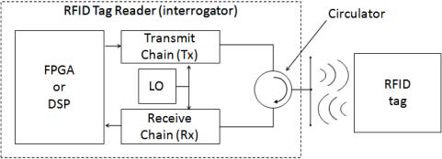

Figure 1: Block Diagram of a Typical RFID Tag/Reader System

Note from Figure 2 that many RFID readers and measurement systems actually use a three-port RF component called a circulator that gives both transmit and receive front ends the ability to use the same antenna. Note that with many RFID, standards, timing information between transmit and receive commands is defined by strict guidelines. In fact, a sort of “handshaking” is required between the tag and reader to complete an interrogation round. This actually creates a unique test challenge because the instrumentation must be capable of the same behavior. On an interrogator, an embedded processor is required to decode and generate commands within a tight timing interval. As discussed in a later section, this design is quite similar to field-programmable gate array (FPGA)-enabled RFID measurement systems, which use similar embedded processing to fully emulate either a tag or a reader.

* **UHF Antenna Characteristics**

One of the most elusive goals of RFID design is the challenge of extending a tag’s read range. At UHF frequencies, this challenge is particularly daunting because a tag’s electromagnetic properties (which determine performance) can be substantially affected by properties of the material on which the tag is applied. In general, two of the most important factors that affect a tag’s read range include efficiency of the antenna and impedance matching between an antenna and chip (or inlay) [2][3][4][6]. For reference, observe the basic design of a UHF RFID tag, shown in Figure 3.

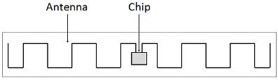

Figure 3. Basic Design of a UHF RFID Tag

The specific tag design shown in Figure 3 is known as the meandering trace design [2]. In some cases, you can tune the resonant frequency of this particular design simply by clipping the trace length [6].

One interesting characteristic of RFID antennas is that they often have impedance that is highly reactive. When a reactive substance is stimulated with an electromagnetic wave, a tag actually reradiates the same electromagnetic wave back at its source. This characteristic of the antenna is actually helpful in RFID systems because it provides the tag with a straightforward mechanism to send an electromagnetic wave to the source without the need of an onboard synthesizer. This method is called backscattering.

Antenna design of RFID tags has already been the subject of significant research. More specifically, this research has examined techniques to tune antennas for operation over a broad frequency range [3]. This document does not describe the design trade-offs that must be made to maximize a tag’s read range. Instead, it examines the measurement techniques that you can use to characterize various aspects of a tag’s performance.

### 3.2.2 Algorithm

The first step of the interrogation round is an interrogator-to-tag (R->T) transmission. The digital message data is typically encoded according to one of several common schemes including Manchester (ISO 14443) and pulse-interval encoding (PIE) (ISO 18000-6C). The encoded message is then modulated with one of several variants of the amplitude shift keying (ASK) modulation scheme. For example, with the EPC Class 1, Gen 2 (ISO 18000-6C) standard, readers can use any of the double-sideband ASK (DSB-ASK), single-sideband ASK (SSB-ASK), and phase-reversal ASK (PR-ASK) options. Of these three options, note that PR-ASK is one of the most interesting. This scheme uses a combination of 180 deg phase transitions every symbol and a 100 percent modulation depth to provide the lowest C/N requirement for error-free communications.

Once the interrogator transmits a command, the electromagnetic wave propagates in free space toward the tag. When the wave reaches the tag, the tag’s antenna is excited and the RF power is converted to DC power through a voltage rectifier. This DC voltage is then able to power the control logic (often employed with a state machine) on the chip, which demodulates the waveform and determines the appropriate next command. A functional block diagram of the chip is illustrated in Figure 4.

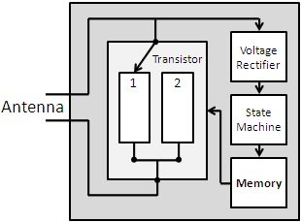

Figure 4: A Functional Block Diagram of an RFID ASIC (inlay)

The chip is also called the “inlay,” and it can be broken down into several functional blocks. The voltage rectifier converts an electromagnetic wave to DC power. The control logic/state machine determines the next command to be sent to the reader. Finally, the transistor enables modulation of the reradiated electromagnetic wave.

### 3.2.3 Equations and calculation

One of the perpetual challenges of RFID tag design is the requirement to maximize tag read range across a broad range of frequencies or on a broad range of deployed objects. Overall, tag read range is determined by several factors including antenna gain, effective area, and impedance matching between the inlay (chip) and the antenna. In some cases, many of these characteristics are also affected by the substrate on which the tag is applied. Thus, various organizations, including the University of Pittsburgh RFID Center of Excellence and Oden Technologies, serve the RFID community by providing a range of consulting services [8][10][11]. In this scenario, a firm wanting to use RFID technology asks a consultant to help determine factors such as ideal frequency usage and best tag placement for a particular application.To understand the challenges of tag read range performance, first take a look at theoretical tag performance. To start with, you can express the total power collected by a tag’s antenna in free space according to the following equation.



Equation 1. This equation shows antenna power affected by antenna gain, wavelength, and distance [2].

As Equation 1 illustrates, the power available at an antenna, Pa, is a function of various factors including the power and gain (efficiency) of the transmitter antenna (Pt and Gt), the distance from the transmitter (r), electromagnetic wavelength (λ), and gain (efficiency) of the RFID tag’s antenna (Gtag). The obvious conclusion from Equation 1 is that to improve read range (r) without increasing transmit power, you must improve the gain of the RFID antenna. As a result, characterization of RFID tags often involves significant characterization of the antenna over a wide range of frequencies [4][5][7].

On the RFID tag reader side, reradiated power is also important. In general, more efficient reradiation of electromagnetic waves translates to easier dynamic range requirements on the RFID reader. Note that reradiated power is also influenced by factors such as antenna gain and tag-antenna impedance matching. This is illustrated in the equations below, which express reradiated power as a function of several factors:



Equations 2 and 3. These equations show antenna power affected by antenna gain, wavelength, and distance [4].

As you can observe from Equation 3, reradiated power is highly dependent on the impedance matching between the inlay and the tag’s antenna. In Equation 3, Za represents the impedance of the antenna and Zc represents the impedance of the chip (inlay). From this equation, you can see that when the impedance of the antenna is zero (short circuit), the tag reradiates four times as much power as a matched antenna. On the other hand, when the antenna impedance is highly reactive (capacitive), a complex conjugate loaded antenna actually reradiates more power than an antenna with zero impedance [4]. While this paper does not explore these trade-offs in-depth, it is worth noting that design decisions such as choice of antenna and inlay impedance/reactance can have a significant impact on tag performance. To examine these trade-offs in-depth, read Theory and Measurement of Backscattering from RFID Tags by Nikitin and Rao [4]. In their article, they not only detail the trade-offs between various combinations of antenna and inlay impedance but also characterize tag performance across the frequency range. You can find a description of the measurement system in the case study Using National Instruments Software and Hardware to Develop and Test RFID Tags by Pavel V. Nikitin of Intermec Technologies Inc. [12].

## 3.3 Embedded System

Arduino Uno is the embedded system in the project. Arduino Uno is a microcontroller board based on the ATmega328 (datasheet). It has 14 digital input/output pins (of which 6 can be used as PWM outputs), 6 analog inputs, a 16 MHz ceramic resonator, a USB connection, a power jack, an ICSP header, and a reset button. It contains everything needed to support the microcontroller; simply connect it to a computer with a USB cable or power it with a AC-to-DC adapter or battery to get started. The Uno differs from all preceding boards in that it does not use the FTDI USB-to-serial driver chip. Instead, it features the Atmega16U2 (Atmega8U2 up to version R2) programmed as a USB-to-serial converter

### 3.3.1 Global Positioning System (GPS)

The Global Positioning System (GPS) is a space based radio navigation system that provides reliable navigation, positioning, and timing services to civilian users on a continuous worldwide basis. GPS receiver retrieves the latitude and longitude and hence helps in determining its position and time [6]. Hence, it can be used to obtain the source and destination locations of a passenger while travelling [7].

## 3.5 Summary

In this chapter, the theoretical part of our project has been described. We have tried to explain how RFID technology works in detail, and the theory of how we can use RFID technology in our system. All necessary equations and calculations have been shown

# Chapter 4

# Structure of the system

## 4.1 Introduction

The whole system consists of a microcontroller controlling bunch of modules for the system. The GPS module gives the location to the microcontroller. Which then process and transmits it to app via Google API. RFID module check and collects fare from passengers NFC cards.

## 4.2 Procedure and Functionality

The system does the following procedure and has these functions.

### 4.2.1 Procedure

*Fig. 4.1. Workflow diagram of the Arduino*

As NFC card are scanned the passenger info gets stores and the fare starts till he gets down and fare is calculated according to that. GPS keeps info of the location and send to the App.

### 4.2.2 Functions

The functions include:

* Track Bus
* Recharge Balance
* Pay with NFC card
* Check Passenger List

## 4.3 Workflow and Algorithms

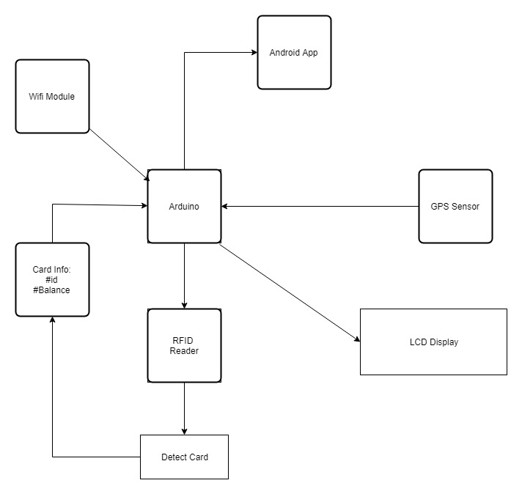

Figure 4.3: System Flow diagram

Fig (4.3) shows how the component of the system are inter-related and communicating with one another.

* GPS sensor module receives the coordinate from satellite. Then Arduino calculates the position of the system (BUS).
* RFID module check for NFC cards. NFC cards are read by the module and send the data from the card to the Arduino.
* LCD displays the info and balance of users which it receives from the Arduino.
* Android App is constantly checking the status and location of Bus. The App let users know where the bus is and how many seats are vacant.
* WIFI Module send data packets from Arduino to the network. WIFI module keeps the system connected to internet.

### 4.3.1 Outline of the workflow

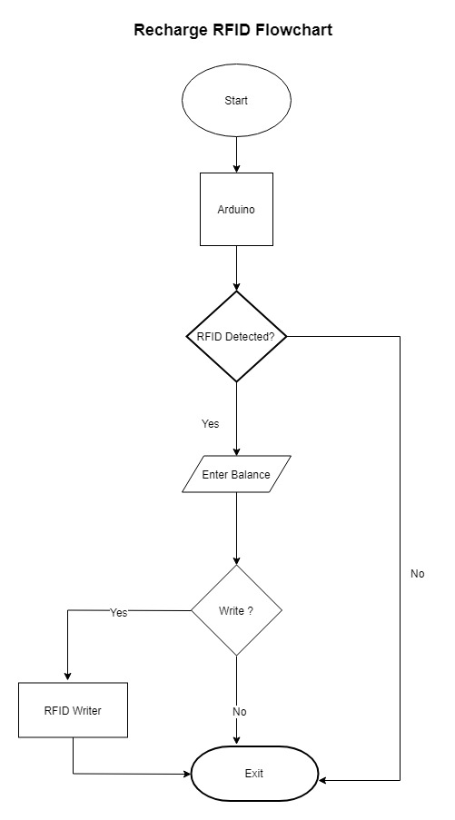

Fig. 4.2. RFID recharge Flowchart

## 4.4 Equipment and Schematic Diagrams

The following electrical equipment were used in this project.

* Microcontroller (Arduino Uno)
* LCD Module
* RFID Module
* GPS Module
* Google API
* Mobile App
* WIFI Module

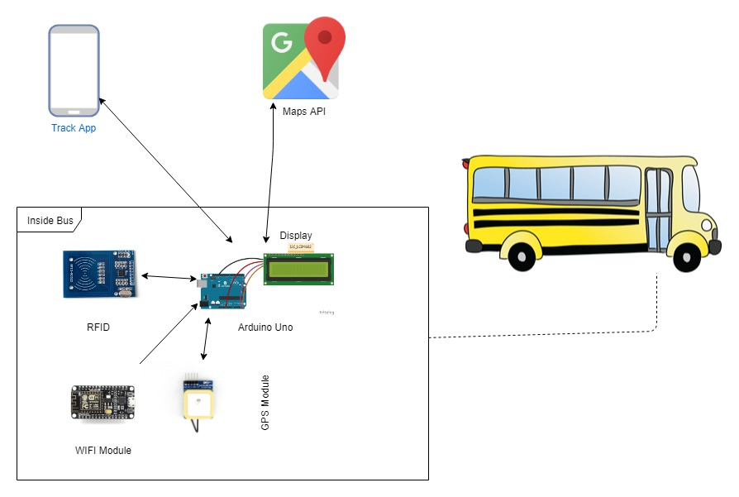

Fig. 4.3. Block diagram of complete System

Fig (4.3) shows the complete system. Arduino is connected with GPS, RFID and LCD module. RFID Module scans RFID cards and reads or writes cards. GPS module constantly keeps track of the longitude and latitude and send the info to the mobile App. LCD displays the info as passenger gets on and off of the bus. Google API shows the location in the App.

## 4.5 Summary

In this chapter, we have described how the system works. The RFID info is sent to microcontroller the is processed to show info and collect fare. WIFI, GPS Module keeps the microcontroller connected to App and send Location. Detailed description of the equipment used will be given in following chapters.

# Chapter 5

# Google Distance Matrix API

## 5.1 Introduction

The Distance Matrix API is a service that provides travel distance and time for a matrix of origins and destinations, based on the recommended route between start and end points.

## 5.2 Google Maps API

Google Maps is a web mapping service developed by Google. It offers satellite imagery, street maps, 360° panoramic views of streets (Street View), real-time traffic conditions (Google Traffic), and route planning for traveling by foot, car, bicycle (in beta), or public transportation.

Google Maps began as a C++ desktop program at Where 2 Technologies. In October 2004, the company was acquired by Google, which converted it into a web application. After additional acquisitions of a geospatial data visualization company and a realtime traffic analyzer, Google Maps was launched in February 2005.[1] The service's front end utilizes JavaScript, XML, and Ajax. Google Maps offers an API that allows maps to be embedded on third-party websites,[2] and offers a locator for urban businesses and other organizations in numerous countries around the world. Google Map Maker allowed users to collaboratively expand and update the service's mapping worldwide but was discontinued from March 2017. However, crowdsourced contributions to Google Maps were not discontinued as the company announced those features will be transferred to Google Local Guides program.[3] Google Maps' satellite view is a "top-down" or "birds eye" view; most of the high-resolution imagery of cities is aerial photography taken from aircraft flying at 800 to 1,500 feet (240 to 460 m), while most other imagery is from satellites.[4] Much of the available satellite imagery is no more than three years old and is updated on a regular basis.[5] Google Maps uses a variant of the Mercator projection, and therefore cannot accurately show areas around the poles.[6]

The current redesigned version of the desktop application was made available in 2013, alongside the "classic" (pre-2013) version. Google Maps for Android and iOS devices was released in September 2008 and features GPS turn-by-turn navigation along with dedicated parking assistance features. In August 2013, it was determined to be the world's most popular app for smartphones, with over 54% of global smartphone owners using it at least once.[7] In 2012, Google reported having over 7,100 employees and contractors directly working in mapping.[8].

## 5.3 Google Distance Matrix API

The Distance Matrix API is a service that provides travel distance and time for a matrix of origins and destinations, based on the recommended route between start and end points. You access the Distance Matrix API through an HTTP interface, with requests constructed as a URL string, using origins and destinations, along with your API key.

Below is a sample response from MATRIX API, in JSON:

|  |
| --- |
| **{    "destination_addresses" : [ "New York, NY, USA" ],    "origin_addresses" : [ "Washington, DC, USA" ],    "rows" : [       {          "elements" : [             {                "distance" : {                   "text" : "225 mi",                   "value" : 361715                },                "duration" : {                   "text" : "3 hours 49 mins",                   "value" : 13725                },                "status" : "OK"             }          ]       }    ],    "status" : "OK" }** |

## 5.4 Summary

The Distance Matrix API of Google and its features have been described in this chapter.

# Chapter 6

# The Microcontroller used in this system: Arduino Uno

## 6.1 Introduction

In our project we have used microcontroller (Arduino Uno) to run the robot according to given command. Circumstances that we find ourselves in today in the field of microcontrollers had their beginnings in the development of technology of integrated circuits. This development has made it possible to store hundreds of thousands of transistors into one chip. That was a prerequisite for production of microprocessors, and the first computers were made by adding external peripherals such as memory, input-output lines, timers and other. Further increasing of the volume of the package resulted in creation of integrated circuits. These integrated circuits contained both processor and peripherals. The microcontroller Arduino mega is described briefly in this chapter.

## 6.2 Arduino Uno

The microcontroller we used in our system is Arduino Uno. Arduino is an open-source computer hardware and software company, project and user community that designs and manufactures microcontroller-based kits for building digital devices and interactive objects that can sense and control objects in the physical world. The project is based on microcontroller board designs, manufactured by several vendors, using various microcontrollers. These systems provide sets of digital and analog I/O pins that can be interfaced to various expansion boards ("shields") and other circuits. The boards feature serial communications interfaces, including USB on some models, for loading programs from personal computers. For programming the microcontrollers, the Arduino platform provides an integrated development environment (IDE) based on the Processing project, which includes support for the C, C++ and Java programming languages.

The first Arduino was introduced in 2005, aiming to provide an inexpensive and easy way for novices and professionals to create devices that interact with their environment using sensors and actuators. Common examples of such devices intended for beginner hobbyists include simple robots, thermostats, and motion detectors.

### 6.2.1 Hardware

Arduino boards are available commercially in preassembled form, or as do-it-yourself kits. The hardware design specifications are openly available, allowing the Arduino boards to be manufactured by anyone. Adafruit Industries estimated in mid-2011 that over 300,000 official Arduinos had been commercially produced, and in 2013 that 700,000 official boards were in users' hands.

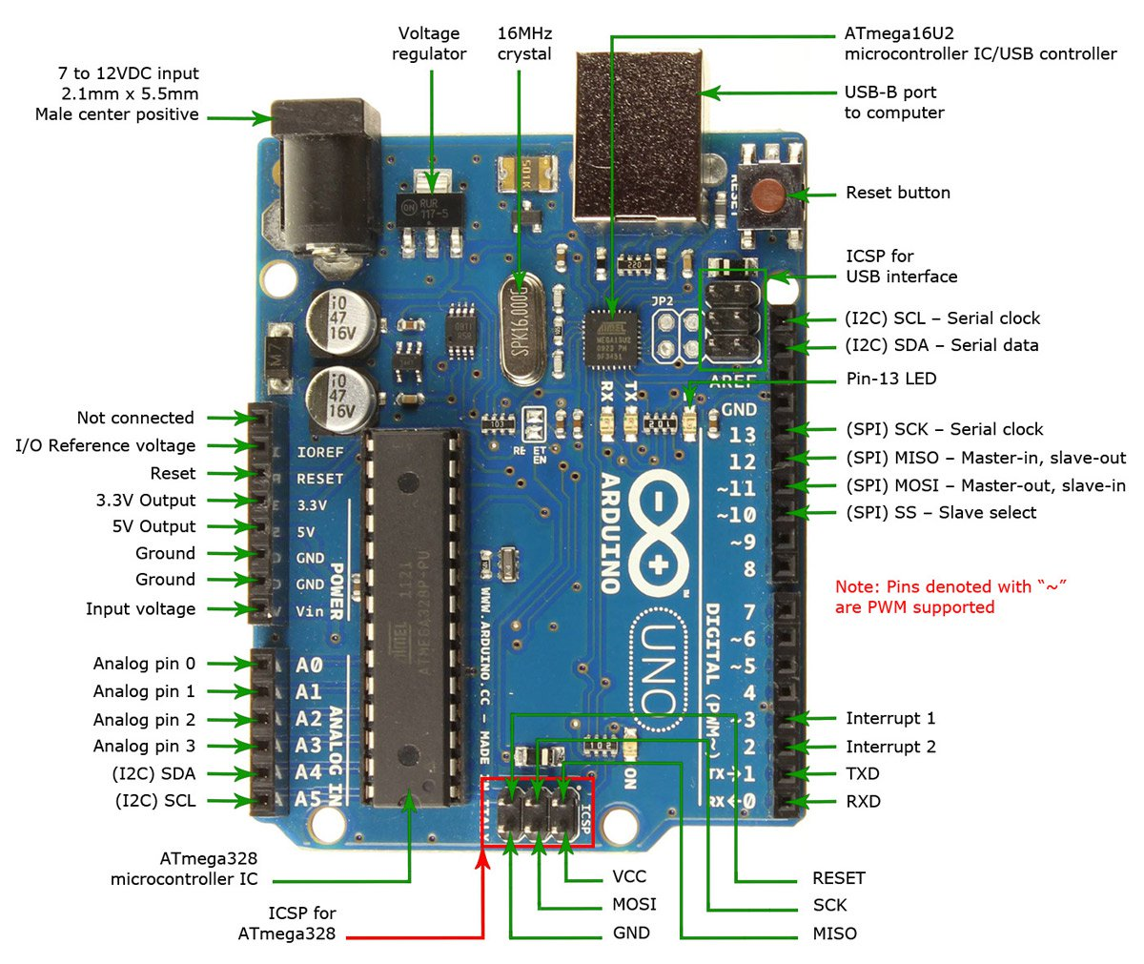

Fig. 6.1. Arduino UNO

An Arduino board consists of an Atmel 8-, 16- or 32-bit AVR microcontroller with complementary components that facilitate programming and incorporation into other circuits. An important aspect of the Arduino is its standard connectors, which lets users connect the CPU board to a variety of interchangeable add-on modules known as *shields*. Some shields 28 communicate with the Arduino board directly over various pins, but many shields are individually addressable via an I²C serial bus—so many shields can be stacked and used in parallel. Official Arduinos have used the megaAVR series of chips, specifically the ATmega8, ATmega168, ATmega328, ATmega1280, and ATmega2560. A handful of other processors have been used by Arduino compatibles. Most boards include a 5 V linear regulator and a 16 MHz crystal oscillator (or ceramic resonator in some variants), although some designs such as the Lily Pad run at 8 MHz and dispense with the onboard voltage regulator due to specific form-factor restrictions. An Arduino's microcontroller is also pre-programmed with a boot loader that simplifies uploading of programs to the on-chip flash memory, compared with other devices that typically need an external programmer. This makes using an Arduino more straightforward by allowing the use of an ordinary computer as the programmer. Currently, optiboot bootloader is the default bootloader installed on Arduino MEGA.

### 6.2.2 Application

* Arduino IDE
* Things Speak IOT Analytics
* RFID Library

## 6.3 Pin out diagram of Arduino UNO

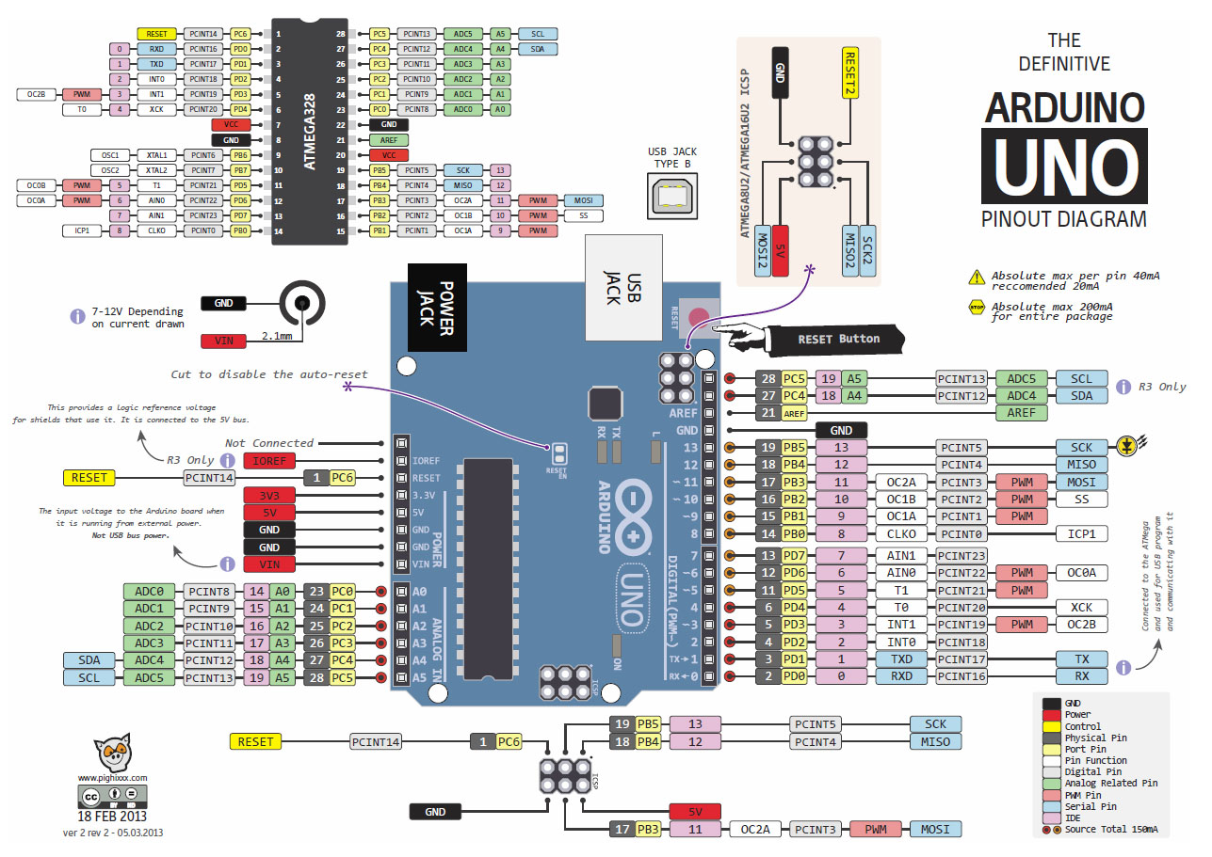

Fig. 6.2. Pin out diagram of Arduino UNO

## 6.4 Summary

The microcontroller used in our system, Arduino UNO, and its applications and pin out diagram along with its features have been described in this chapter. The next chapter describes the different modules used in this project.

# Chapter 7

# Modules used in this system

## 7.1 Introduction

The different modules used in our system and their functions are described in this chapter.

The following modules have been used in the construction of the robot:

* RFID Module (MFRC-522)
* GPS Module (NEO-6M)
* LCD Display (16x2)

## 7.2 RC522 RFID Module 13.56MHz

This low cost MFRC522 based RFID Reader Module is easy to use and can be used in a wide range of applications. The MFRC522 is a highly integrated reader/writer IC for contactless communication at 13.56 MHz

**Features**:

* MFRC522 chip based board
* Operating frequency: 13.56MHz
* Supply Voltage: 3.3V
* Current: 13-26mA
* Read Range: Approx 3cm with supplied card and fob
* SPI Interface
* Max Data Transfer Rate: 10Mbit / s

**Package contents**

* 1 x Mifare RC522 Card Read Antenna RF Module
* 1x RFID plain white Card
* 1x RFID FOB
* 1x 8pin right angle header pins
* 1x 8pin straight header pins

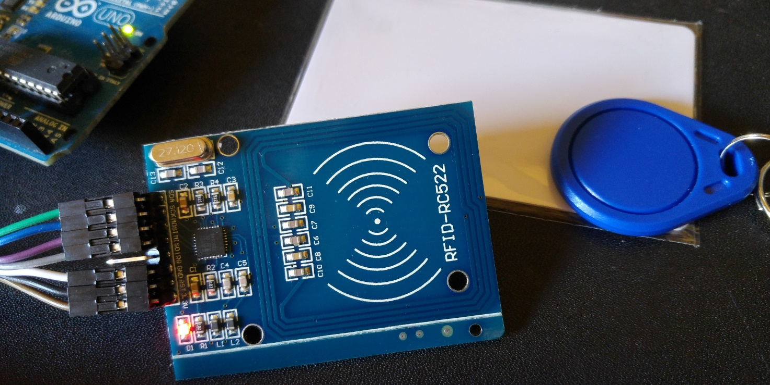

Fig. 7.1.RFID Module

## 7.3 GPS Module (NEO-6M)

The NEO-6M GPS module is a well-performing complete GPS receiver with a built-in 25 x 25 x 4mm ceramic antenna, which provides a strong satellite search capability. With the power and signal indicators, you can monitor the status of the module. Thanks to the data backup battery, the module can save the data when the main power is shut down accidentally. Its 3mm mounting holes can ensure easy assembly on your aircraft, which thus can fly steadily at a fixed position, return to Home automatically, and automatic waypoint flying, etc. Or you can apply it on your smart robot car for automatic returning or heading to a certain destination, making it a real "smart" bot!

**Features**:

1) A complete GPS module with an active antenna integrated, and a built-in EEPROM to save configuration parameter data.

2) Built-in 25 x 25 x 4mm ceramic active antenna provides strong satellite search capability.

3) Equipped with power and signal indicator lights and data backup battery.

4) Power supply: 3-5V; Default baud rate: 9600bps.

5) Interface: RS232 TTL

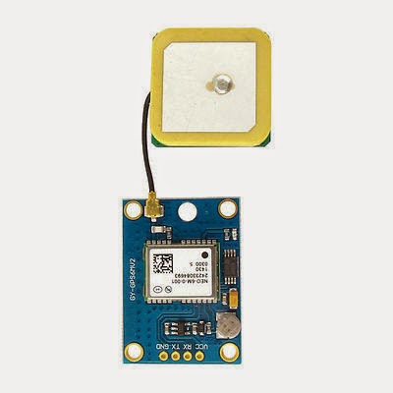

Fig. 7.2. GPS Module NEO-6M

## 7.4 LCD Display (16x2)

LCD (Liquid Crystal Display) screen is an electronic display module and find a wide range of applications. A 16x2 LCD display is very basic module and is very commonly used in various devices and circuits. These modules are preferred over seven segments and other multi segment LEDs. The reasons being: LCDs are economical; easily programmable; have no limitation of displaying special & even custom characters (unlike in seven segments), animations and so on.

A 16x2 LCD means it can display 16 characters per line and there are 2 such lines. In this LCD each character is displayed in 5x7 pixel matrix. This LCD has two registers, namely, Command and Data.The command register stores the command instructions given to the LCD. A command is an instruction given to LCD to do a predefined task like initializing it, clearing its screen, setting the cursor position, controlling display etc. The data register stores the data to be displayed on the LCD. The data is the ASCII value of the character to be displayed on the LCD. Click to learn more about internal structure of a LCD.

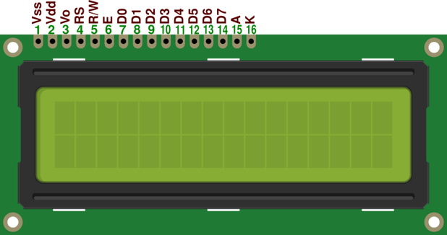

Fig. 7.3: LCD Display 16x2

## 7.5 ESP8266 WIFI Module

ESP8266 offers a complete and self-contained Wi-Fi networking solution, allowing it to either host the application or to offload all Wi-Fi networking functions from another application processor.

When ESP8266 hosts the application, and when it is the only application processor in the device, it is able to boot up directly from an external flash. It has integrated cache to improve the performance of the system in such applications, and to minimize the memory requirements.

Alternately, serving as a Wi-Fi adapter, wireless internet access can be added to any microcontroller-based design with simple connectivity through UART interface or the CPU AHB bridge interface.

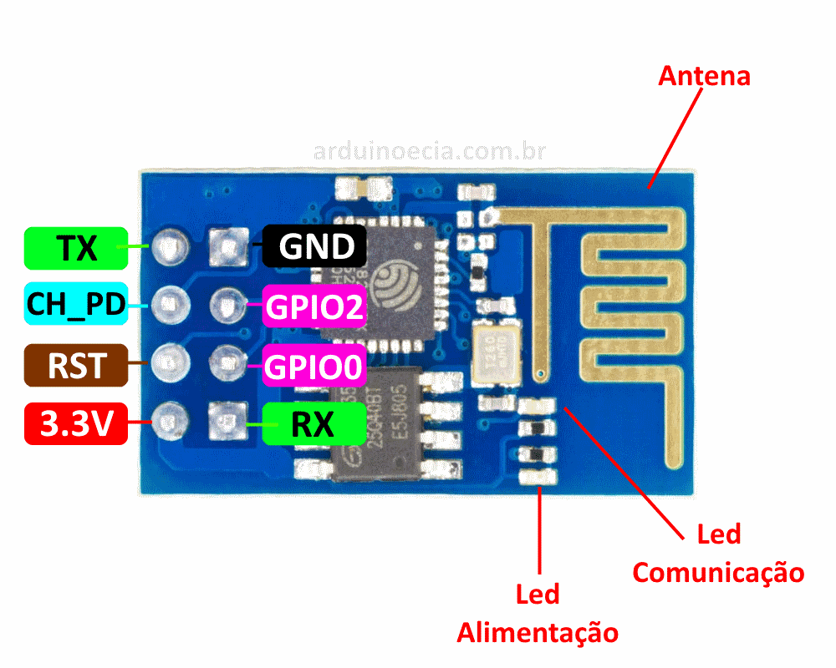

Figure 7.5: ESP8266 WIFI Module

**ESP8266 Features**

* 802.11 b/g/n protocol
* Wi-Fi Direct (P2P), soft-AP
* Integrated TCP/IP protocol stack
* Integrated TR switch, balun, LNA, power amplifier and matching network
* Integrated PLL, regulators, and power management units
* +19.5dBm output power in 802.11b mode
* Integrated temperature sensor
* Supports antenna diversity
* Power down leakage current of < 10uA
* Integrated low power 32-bit CPU could be used as application processor
* SDIO 2.0, SPI, UART
* STBC, 1×1 MIMO, 2×1 MIMO
* A-MPDU & A-MSDU aggregation & 0.4µs guard interval
* Wake up and transmit packets in < 2ms
* Standby power consumption of < 1.0mW (DTIM3)

## 7.6 Summary

In this chapter, we have described the different modules used in our system- RC522 RFID Module, GPS Module, LCD Module, WIFI Module.

# Chapter 8

# Mechanical Description

## 8.1 Introduction

The mechanical construction of the device is described in detail in this chapter. The mechanical part of the device has been designed and made from scratch entirely by us. We designed this device with Arduino, breadboard, wires, modules etc. We have used 5 mm thick PVC boards for the construction of the body. The mechanical measurements and explanations of the constructions are discussed below.

## 8.2 Mechanical measurements and explanations

The device has a base which is 5 mm thick. The two breadboards are connected with base. The Arduino is placed beside the breadboards on the base. There is a RFID reader which will read the information of the passengers. There is a Wifi module, GPS module in our device. We will place these modules with Arduino. The display is placed on the breadboard. When RFID reader reads data from the card then it will send the information via Wifi module to the server. GPS module helps us to locate the location of the bus and calculate fares.

## 8.3 Summary

In this chapter, the mechanical construction of the device has been described in detail. Detailed explanation of how each of the mechanical components works has also been given here.

# Chapter 9

# Compliance with standards

## 9.1 Introduction

There are several international standards which a system should meet, among which the IEEE, US and European standards are noteworthy to mention. The compliance of our designed system to all these standards is discussed in this chapter.

## 9.2 Compliance with IEEE standards

There are a few distinct guidelines put forward by IEEE Standards affiliation. The equipment we have used for our project are also used in most of the IEEE standard projects like Arduino Uno, RFID Module, LCD Display etc. Our system is safe, beneficial for the disabled, and uses equipment that do not pose any threat to the environment. We could not find any exact standard related to our project, however, we used Wireless technology to wirelessly communicate with the microcontroller, and our project successfully met the IEEE standardized Wireless IEEE 802.11 requirement.

## 9.3 Compliance with US standards

In case of US standards, we could not find exact standard for our system. However, there were some standards that could be attributed to our project.

## 9.4 Compliance with European standards

In case of European standards, we could not find exact standard for our system. However, there were some standards that could be attributed to our project

## 9.5 Summary

The different standards of safety, regulations and law that are prevalent have been analyzed in this chapter, and how the system we designed meets the relevant regulations set by the IEEE, US and European standards has been discussed.

# Chapter 10

# Design Impact

## 10.1 Introduction

The different ways in which our designed project leaves an impact, and how its manufacturability and sustainability is discussed in this chapter.

## 10.2 Economic impact

This device allows the passengers to get their bus services without any hassle. This could save up time and could positively affect the economy. It can be used by passengers during office hours which can save much more time. Economic impact would not be that significant, Still, an automatic bus system could be used for saving time, money etc. Thus it can be expected to affect the economy in a positive way.

## 10.3 Environmental impact

Our project is free from all sorts of materials and chemicals that may harm the wild life or the environment. Though our project may not aid the environmental development, it in no way harms it. So it is safe to say that our project does not have any negative environmental impact.

## 10.4 Social impact

Our project can be put to all kind of city bus services. It can be used to ensure vacant seats, save time and so on. It can open up a new era in bus services. Thus we can say that it is expected to have a remarkable social impact.

## 10.5 Political impact

Our project does not have any direct impact on the political aspect.

## 10.6 Ethical impact

The aim of our project is to save time and money of people and make their life easier, and open up new possibilities for research and development in this field. It intends to help people. Thus it can be said that the project has a positive ethical impact.

## 10.7 Health and safety impact

The vision for the project was to positively impact the health and safety of its user. By our Android app you can see the arrival time of buses. So that you don’t have to stand in a hot sunny day or heavy rainy day. Another point worth mentioning is that our project does not use any harmful chemicals or substances, or emit any harmful radiation that could negatively affect the manufacturers, users or the environment. Thus we can say that it has an overall positive health and safety impact.

## 10.8 Manufacturability

The device requires components which are widely available. The mechanical design is simple and has been precisely documented. Thus it would not be a complex system to manufacture.

## 10.9 Sustainability

Our device has been made using breadboard, PVC and all parts are rigid and fixed strongly to each other so there is very little chance of the components breaking down, loosening, or falling apart. The design is expected to be durable and resistant to pressure or stress of any kind. The device has been designed so that it can even move without difficulty. Thus it is expected to sustain for a long period of time.

## 10.10 Summary

The different aspects of this project’s impact and its manufacturability and sustainability have been discussed in this chapter.

# Chapter 11

# Results and Discussion

## 11.1 Introduction

The results and findings of our project are discussed in this chapter. We identified the radio frequency of our RFID cards which is used to track individual. By the wifi module we will access internet to connect with our server and app. The GPS module works with the help of Google Map API. By the help of Google Map API we can easily calculate the distance covered and the fare.

**11.2 Result and findings of location tracing**

The data is received by the device then it will send it to the server. Then the it will trace your location through Google Map API and calculate your distance and fare. We took some readings and it showed us the location of user but the location has some error like few meters which is only 2-3%.

**11.3 Limitations**

Our project has some limitations like it doesn’t have unlimited balance for passengers. For this project we have to connect with the internet all time. If the internet doesn’t work then the device won’t work properly. Because the Google Map API cannot trace your location and distance you have covered. Other limitation is, if someone forget to punch the RFID before get down from the bus then it will continue to counting the fare.

**11.4 Summary**

In this chapter, we have described and discussed the results of our project, which tracing the location of passengers and calculate the distance covered through Google Map API.

# Chapter 12

# Project Budget & Timeline

## 12.1 Introduction

The project timeline duration and budget will be discussed in this chapter.

## 12.1 Project Budget

|  |  |
| --- | --- |
| Hardware Parts | Price (Tk) |
| Arduino | 500 |
| RC522 RFID Card Reader/Detector | 235 |
| ESP8266 Wi-Fi Module | 245 |
| GPS Module | 1400 |
| LCD | 200 |
| Total | 2580 |

Table 4: Budgets of “Bus Service Automation Process” Project

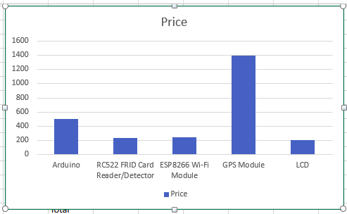

Figure 12.1: Project Budget

## 12.3 Project Timeline

|  |  |  |  |  |
| --- | --- | --- | --- | --- |
| WBS | Task Name | Start Date | Finish Date | Duration |
| 1 | Project Design | 1-Jun | 7-Jun | 6 |
| 2 | Project Report | 9-Jul | 12-Jul | 4 |
| 3 | Hardware Testing | 12-Jul | 14-Jul | 2 |
| 4 | Hardware Assemble | 15-Jul | 18-Jul | 3 |
| 5 | Hardware Prototype Testing | 18-Jul | 21-Jul | 3 |
| 6 | Building App | 22-Jul | 24-Jul | 2 |
| 7 | System Testing | 25-Jul | 26-Jul | 1 |
| 8 | Connecting to App | 27-Jul | 29-Jul | 2 |
| 9 | Final System Construction | 30-Jul | 12-Aug | 1 |
| 10 | Testing and Debugging System | 13-Aug | 17-Aug | 4 |
| 11 | Project Demonstration |  | 18-Aug |  |

*Table 5: Time table of “Bus Service Automation” Project*

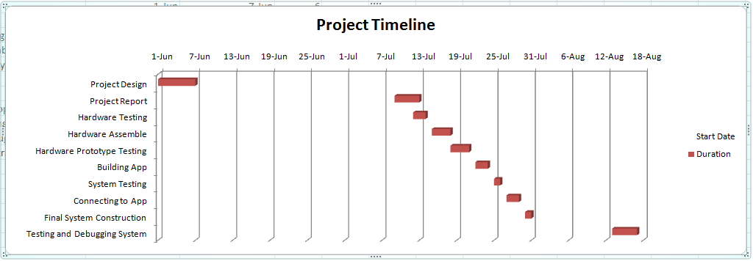

*Figure 12.2: Project Timeline*

# Chapter 13

# Conclusion

In this project, we have focused on two things – RFID based bus ticketing and an apps to see the location of the bus and available seats in the bus.

The fare collection problem has been eliminated Moreover, the project phase is completed successfully by using smart card .This project is made with pre-planning, that it provides flexibility in operation. This innovation has made more desirable and economical. This project “AUTOMATIC BUS FARE COLLECTION SYSTEM USING RFID “ is designed with the hope that it is very much economical and helpful for passengers and as well as conductors during Journey.

# 

# Bibliography

[1] EPCTM Radio-Frequency Identification Protocols Class-1 Generation-2 RFID Protocol for Communications at 860 MHz – 960 MHz Version 1.10, EPCglobal Inc, 2006.

[2] Dobkin, Daniel M. “The RF in RFID,” Elsevier Inc., 2008.

[3] Ng, Mun Leng. Leong, Kin Seong. Cole, Peter H. Analysis of Constraints in Small UHF RFID Tag Design, 2005.

[4] Nikitin, P. V. and K. V. S. Rao, Theory and measurement of backscattering from RFID tags, IEEE Antennas and Propagation Magazine, vol. 48, no. 6, pp. 212-218, December 2006.

[5] Nikitin, P. V., K. V. S. Rao, and R.D. Martinez, “Differential RCS of RFID tag,” Electronics Letters, April 12, 2007, Vol. 43, No. 8.

[6] Nikitin, P. V., K. V. S. Rao, and S. Lazar, “An overview of near field UHF RFID,” IEEE RFID 2007 Conference, March 2007.

[7] Rao, K. V. Seshagiri, Pavel V. Nikitin, and Sander F. Lam. “Antenna Design for UHF RFID Tags: A Review and a Practical Application.” IEEE Transactions on Antennas and Propagation, VOL. 53, NO. 12, December 2005.

[8] S. Dontharaju, S. Tung, A. K. Jones, L. Mats, J. Panuski, J. T. Cain, and M. H. Mickle, “The Unwinding of a Protocol,” IEEE Applications & Practice, RFID Series, Vol. 1, No. 1, pp. 4 - 10, April 2007.

[9] Jones, A. K., Dontharaju, S., Mats, L., Cain, J. T., and Mickle, M. H., “Exploring RFID Prototyping in the Virtual Laboratory,” MSE Conference, 2007.

[10] Sweeney, Patrick J. RFID for Dummies, pp.119-138. Wiley Publishing Inc, 2005.

[11] : A. Oudah 2016 IOP Conf. Ser.: Mater. Sci. Eng. 114 012146.

[12] Mandeep K., Manjeet S., Neeraj M. and Parvinder S. S.: RFID technology principles, advantages, limitations & its applications. In: Proceedings of the International Journal of Computer and Electrical Engineering, 2011, February Vol.3, No.1, 1793-8163.

[13] Kaushal M. A., Harshil M. G., Priyank J. S.: Automatic Ticket Vending via Messaging Service ATVMS. In: International Journal of Computer Applications, Volume 42, No.17, March 2012.

[14] Punit D., Benjamin L., Devin T.: RFID navigation system for the visually impaired. In: A Major Qualifying Project submitted to the faculty of Worcester Polytechnic Institute for the Degree of Bachelor of Science, April 25, 2012.

[15] N. Nandini, S. Pavithra, G. Sindhuja, K. Sukanya: Embedded based passenger infotainment system. In: International Journal of Electrical, Electronics and Data Communication, ISSN (p): 2320- 2084, Volume-1, Issue-1, March 2013. iMEC-APCOMS 2015 IOP Publishing IOP Conf. Series: Materials Science and Engineering 114 (2016) 012146 doi:10.1088/1757-899X/114/1/012146 9

[16] G. Lavanya, Preethy W., Shameem A., Sushmitha R.: Passenger bus alert system for easy navigation of blind. In: Proceedings of the International Conference on Circuits, Power and Computing Technologies ICCPCT, March 2013.

[17] Nandhini a, Sunitha. (2017). Automatic Bus Fare Collection System using RFID. International Journal of Advanced Research in Computer Engineering & Technology. Volume 6. 218-223.